**

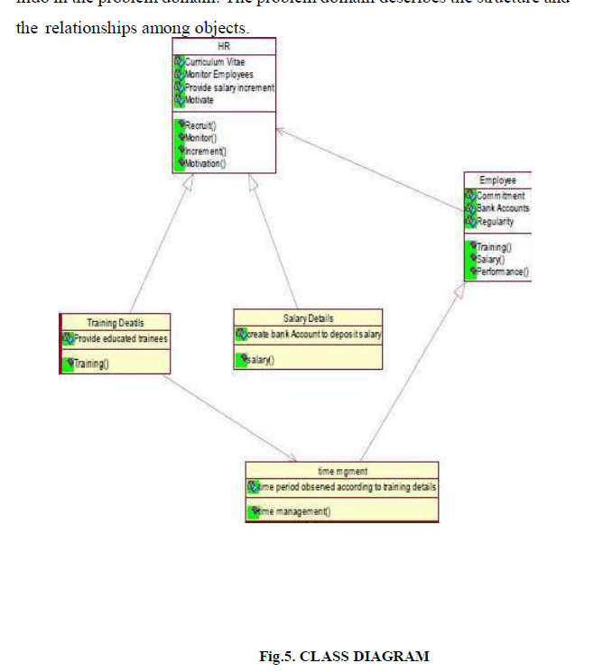

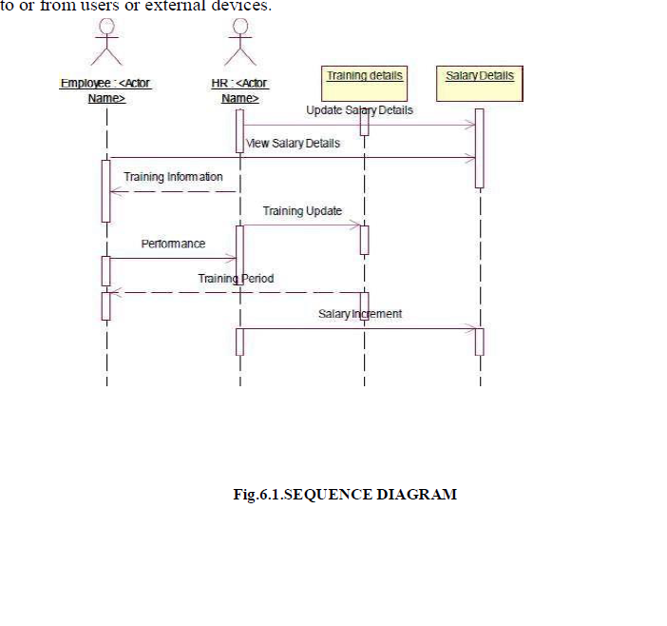

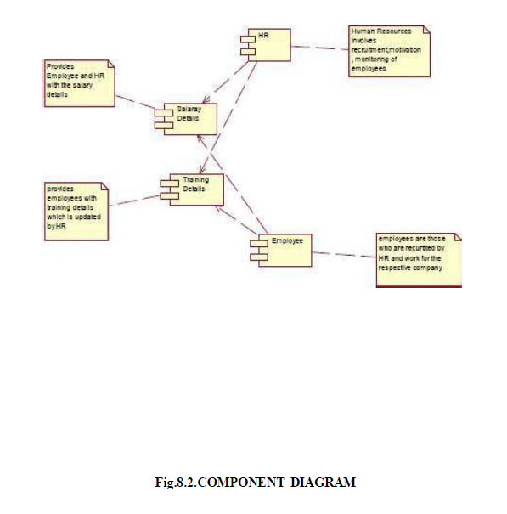

**OOAD QUESTIONS**

|  |  |
| --- | --- |
| 1. 2 | a) Draw class diagrams to identify and describe key concepts and their relationships for airline system b)Identify the conceptual classes and develop a Domain Model for the above Class Diagrams |
| 1. 3 | Draw the Activity and State Diagrams for a railway reservation system. |
| 1. 5 | a) Identify Use Cases and develop the Use Case model for ticket reservation system. b) Draw the Collaboration Diagrams for food ordering system.  Online ticket booking system | Use Case Diagram Template |
| 1. 6 | a) Draw deployment diagram for ecommerce website to model the runtime architecture of your application.  b) Apply appropriate design patterns to improve the reusability and maintainability of  the banking system. |
|  |  |
| 1. 8 | a)Draw class diagrams to identify and describe key concepts and their relationships for railway reservation system.  b)Identify the conceptual classes and develop a Domain Model for the above Class Diagrams  Railway Model | IT-Dinosaurus Blog  Railway Reservation System Class Diagram | Academic Projects |
|  |  |
| 1. 9 | Using the identified application airline system, find the interaction between objects and represent them using UML Sequence and Collaboration Diagrams.  Sequence Diagram for Airline Reservation System  Collaboration Diagram Online Flight Ticket Reservation System Rational Rose |
| 1. 10 | a)Identify Use Cases and develop the Use Case model for banking application  b) Using the identified application hospital management system, find the interaction between objects and represent them using UML Sequence diagram    Use case diagram providing an overview of the basic banking services. |  Download Scientific Diagram |
| 1. 14 | Draw the Activity and State Diagrams for an hotel management system    Activity Diagram of Hotel Reservation System | Download Scientific Diagram |
| 1. 16 | a)Draw class diagrams to identify and describe key concepts and their relationships for banking application.  b)Identify the conceptual classes and develop a Domain Model for the above Class Diagrams  Diagram Class for banking management. | Download Scientific Diagram |
| 1. 24 | a)Draw the UML package diagram for Chat application to show the User Interface, Domain objects and Technical services.  b) Draw the Collaboration Diagrams for student management system.  Collaboration diagram for Course Registration and Examination module |  Download Scientific Diagram  Package diagram for the server component. The component Chat Server... |  Download Scientific Diagram |
| 1. 27 | Draw the Activity and State Diagrams for an airline reservation system |
| 1. 28 | a) Identify Use Cases and develop the Use Case model for online shopping system.  b) Draw State Diagram for an ticket reservation system |
| 1. 29 | a) Draw deployment diagram for Hotel management system to model the runtime architecture of your application.  b) UML Sequence diagram for library management system  Deployment Diagram for Hotel Management System |
| 1. 30 | a)Draw class diagrams to identify and describe key concepts and their relationships online shopping system.  b)Identify the conceptual classes and develop a Domain Model for the above Class Diagrams |
| 1. 31 | a) Draw component diagram for ATM system assuming that you will build your system by reusing existing components along with few new components.  b) Draw the Activity Diagrams for an restaurant system |
| 1. 32 | Draw the Activity and State Diagrams for an ticket reservation system |
| 1. 33 | Using the identified application hospital management system, find the interaction between objects and represent them using UML Sequence and Collaboration Diagrams. |
| 1. 34 | a)Identify Use Cases and develop the Use Case model for Telecommunication applications.  b) UML Sequence diagram for library management system. |
| 1. 36 | Using the identified application online shopping system, find the interaction between objects and represent them using UML Sequence and Collaboration Diagrams. |
|  | a)Draw the UML package diagram for ATM system to show the User Interface, Domain objects and Technical services.  b) Draw the Collaboration Diagrams for hospital management system |
|  | a) Draw component diagram for hospital management assuming that you will build your system by reusing existing components along with few new components.  b) Draw the State Diagrams for an restaurant system |
|  | Using the identified application banking system, find the interaction between objects and represent them using UML Sequence and Collaboration Diagrams. |
|  | a)Draw class diagrams to identify and describe key concepts and their relationships online shopping system.  b)Identify the conceptual classes and develop a Domain Model for the above Class Diagrams |
|  | Draw the Activity and State Diagrams for an banking system. |
|  | a) Draw component diagram for hotel management system assuming that you will build your system by reusing existing components along with few new components.  b) UML Sequence diagram for hotel management system. |
|  | a)Draw class diagrams to identify and describe key concepts and their relationships for Telecommunication applications.  b)Identify the conceptual classes and develop a Domain Model for the above Class Diagrams. |
|  | Using the identified application student management system, find the interaction between objects and represent them using UML Sequence and Collaboration Diagrams. |
|  | a)Draw the UML package diagram for food ordering system to show the User Interface, Domain objects and Technical services.  b) Draw the Activity Diagrams for student management system. |
|  | Using the identified application ATM system, find the interaction between objects and represent them using UML Sequence and Collaboration Diagrams. |
|  | a)Identify Use Cases and develop the Use Case model for student management system.  b) UML Sequence diagram for online booking system. |
|  | a)Draw class diagrams to identify and describe key concepts and their relationships for a smart house application.  b)Identify the conceptual classes and develop a Domain Model for the above Class Diagrams |
|  | Using the identified application website development system, find the interaction between objects and represent them using UML Sequence and Collaboration Diagrams. |
|  | a)Identify Use Cases and develop the Use Case model for smart house application.  b) UML Sequence diagram for banking system. |
|  | a) Draw component diagram for Online shopping system assuming that you will build your system by reusing existing components along with few new components.  b) Draw the Activity Diagrams for online ticket booking system |
|  | a)Draw the UML package diagram for library management system to show the User Interface, Domain objects and Technical services.  b) Draw the Collaboration Diagrams for hospital management system |

